Group 40 - Design Documentation

Studioruum (Study Material Sharing Platform)

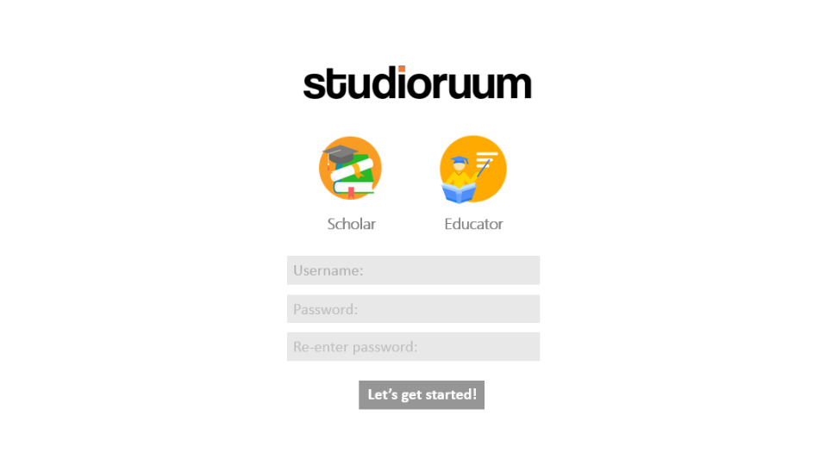

This document aims to outline the general structure and composition of the system we aim to produce. Following on from the feedback given on the requirements, we have still maintained our previous decision to stick with a typical database for our data model, as applications that provide some of the functions we aim to implement (eg. Anki, Notion) seem to use a standard database to store the flashcards they utilise.

The amendments suggested in the agreed requirements were also sound, with the addition of a mobile application. Other than this, the “chatroom for scholars” was already partially planned as a “foruum”, a public place that can allow scholars to discuss a topic (which may or may not be attached to the classroom/classruum of an educator). Additionally, the resources collated were planned to be tested via a quiz, which seems to provide a similar assessment functionality as the online tests, though the actual collection of scores does not need to be made available to educators, as the main purpose of the application is not focused on marking the completion of particular homework style-tasks.

**Mission Statement**

“We aim to produce a comprehensive learning application that can help with the study of different topics, both academic and personal (eg. Learning university modules or foreign languages). Our system will revolve around scholars (the general user) and educators (users with more capabilities to share material with groups) who can both create flashcards, notes, dictionaries and other types of content to aid in the learning process, which can be reviewed in various different ways.“

-Lloyd Jones, Daniel Ponturo, Bobby Chase-Davies, Lachlan Smith, Tyler Bunsie and Jordan Clewlow

# Global Logical Data Model

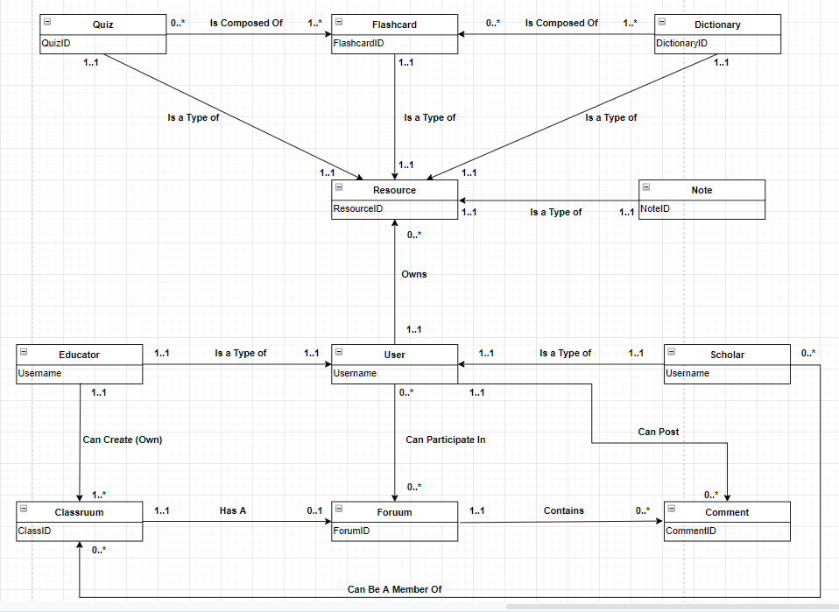

The main entities within our system comes down to ***users*** and ***resources***. When referring to a resource, this means any data item a user can create that can hold formatted text to aid with the learning process. As such, all of the different types of resources are labelled as such.

One special type of resource would be the ***flashcard***, which is a simple two-sided set of text. The main interesting point, however, is that multiple flashcards can either be combined into a ***dictionary***, or into a ***quiz***. These two structured are both resources, but fundamentally consist of a number of flashcards.

In terms of user, we have already discussed in the requirements the importance of ***scholars*** and ***educators***, which can generally be thought of as *students* and *teachers*. They are both types of users, with the main distinction being the ability of educators to ***create classruums*** and the ability of scholars to ***join classruums***. A classruum is essentially a public domain which can have an attached foruum, and it also acts as a sort of file sharing hub for educators to send their resources across to scholars within the classruum. Additionally, these ***foruums*** can exist on their on own, as part of a general topic and not a particular educator’s classroom, and comments can be placed on them by any kind of user, in a similar manner to public forum.

The data dictionary on the next page shows the entities that are structured here, with the different constraints, limitations and explanations necessary to understand the role they play in the system at large.

# Data Dictionary

|  |  |  |  |
| --- | --- | --- | --- |
| **Entity Name** | **Description** | **Aliases** | **Occurrence** |
| Quiz | A sorted collection of flashcards which can be from different sets of Dictionaries | Test | Zero or more Quizzes are composed by one or more Flashcards. Each Quiz is a type of resource |
| Flashcard | A resource containing two sides of text |  | Each Flashcard is a type of Resource |
| Dictionary | A collection of flashcards related to a topic | Deck | One or more Dictionaries is composed by zero or more Flashcards. Each Dictionary is a type of Resource |
| Resource | Some form of learning material | Item | A Resource can be owned by one and only one user |
| Note | A resource containing one side of text, which can be formatted according to the user |  | Each Note is a type of Resource |
| User | Someone that has access to the system | Account | One user can own multiple Resources. Zero or more Users can participate in Foruums |
| Scholar | General user who does not have class creating privileges | Student | Each and every Scholar is a type of User |
| Educator | User with the ability to create and manage classes | Teacher | Each and every Educator is a type of User. One Educator can own one or multiple Classruums |
| Classruum | A group that allows Educators to share resources with Scholars | Class | One or multiple Classruums can be owned by one Educator |
| Foruum | A public domain conversation hub which can be directly related to a specific Classruum | Forum | A single Forum can or cannot be directly related to a specific Classruum |
| Comment | An interaction posted by the User on a specific Foruum | Interaction | Zero or more Comments are contained in a particular Forum |

|  |  |  |  |  |
| --- | --- | --- | --- | --- |
| **Entity** | **Multiplicity** | **Relationship** | **Multiplicity** | **Entity** |
| Quiz  Quiz | 0..*  1..1 | IsComposedOf  IsaTypeOf | 1..*  1..1 | Flashcard  Resource |
| Flashcard | 1..1 | IsaTypeOf | 1..1 | Resource |
| Dictionary  Dictionary | 1..*  1..1 | IsComposedOf  IsaTypeOf | 0..*  1..1 | Flashcard  Resource |
| Resource | None | None | None | None |
| Note | 1..1 | IsaTypeOf | 1..1 | Resource |
| User  User  User | 1..1  0..*  1..1 | Owns  CanParticipateIn  CanPost | 0..*  0..*  0..* | Resource  Foruum  Comment |
| Scholar  Scholar | 1..1  0..* | IsaTypeOf  CanBeAMemberOf | 1..1  0..* | User  Classruum |
| Educator  Educator | 1..1  1..1 | IsaTypeOf  CanCreate | 1..1  1..* | User  Classruum |
| Classruum | 1..1 | HasA | 0..1 | Foruum |
| Foruum | 1..1 | Contains | 0..* | Comment |
| Comment | None | None | None | None |

|  |  |  |  |  |
| --- | --- | --- | --- | --- |
| **Entity** | **Attributes** | **Description** | **Data type and Length** | **Nulls** |
| Quiz | ResourceID  QuizName  QuizTopic | Uniquely identifies the quiz  Name of the Quiz  Topic of the Quiz | 6 variable characters  30 variable characters  30 variable characters | No  No  Yes |
| Flashcard | ResourceID  DictionaryID  QuizID  FrontContent  BackContent | Uniquely identifies the flashcard  Identifies Deck containing flashcard  Identifies containing Quiz  Content (text, etc) on the front of the card  Content (text, etc) on the front of the card | 6 variable character  6 variable characters  6 variable charcaters  255 variable characters  255 variable characters | No  Yes  Yes  No  No |
| Dictionary | ResourceID  DictionaryName | Uniquely identifies Dictionary  Name of the Dictionary | 6 variable characters  30 variable characters | No  No |
| Resource | ResourceID  UserID  Resource_Type  ResourceName  Privacy | Uniquely identifies Resource  Identifies user owning Resource  The type of Resource it is  The name of the Resource  The access level of the resource for non owners(public, private, shared) | 6 variable characters  6 variable charaters  10 Variable characters  30 Variable characters  7 Variable characters | No  No  No  No  no |
| Note | ResourceID  NoteTitle  NoteContent | Uniquely identifies Note  Title of the Note  Content (text, etc) of the note | 6 variable characters  30 variable characters  255 variable characters | No  No  No |
| User | Time_Created  Username  Email  Hashed_Password  Account_Type  ClassID | The time the account was created  Username of User  Email of User  Password for the User account  Identifies the type of account (educator or scholar)  Identifies which class the user is a member of | TimeStamp  30 variable characters  50 variable characters  127 variable characters  8 Variable characters  5 variable characters | No  No  No  No  No  Yes |
| Scholar | ScholarID  UserID | Uniquely identifies Scholar  Uniquely identifies User | 6 variable integers  6 variable integers | No  No |
| Educator | EducatorID  UserID | Uniquely identifies Educator  Uniquely identifies User | 6 variable integers  6 variable integers | No |
| Classruum | ClassID  EducatorID  ClassName | Uniquely identifies Classruum  Identifies owning Educator  Name of the Classruum | 5 variable characters  5 variable charcaters  30 variable characters | No  No  No |
| Foruum | ForumID  ClassID  ForumTitle | Uniquely identifies Foruum  Identifies Class tied to Foruum  Title of the Foruum | 6 variable integers  6 variable integers  30 variable characters | No  Yes  No |
| Comment | CommentID  ForumID  CommentContent  UserID | Uniquely identifies Comment  Identifies Foruum containing the comment  Content (text, etc) of the Comment  Identifies the User that posted the Comment | 6 variable integers  6 variable integers  255 characters  8 variable characters | No  No  No  No |

|  |  |  |  |  |
| --- | --- | --- | --- | --- |
| **Entity** | **Attributes** | **Description** | **Key** | **Nulls** |
| Quiz | ResourceID  QuizName  QuizTopic | Uniquely identifies a quiz  Name of the Quiz  Topic of the Quiz | Primary key | No  No  Yes |
| Flashcard | ResourceID  DictionaryID  QuizID  FrontContent  BackContent | Uniquely identifies flashcard  Uniquely identifies containing Deck  Uniquely identifies containing Quiz  Content (text, etc) on the front of the card  Content (text, etc) on the front of the card | Primary key | No  No  No  No  No |
| Dictionary | ResourceID  DictionaryName | Uniquely identifies Dictionary  Name of the Dictionary | Primary key | No  No  No |
| Resource | ResourceID  UserID  Resource_Type  Privacy | Uniquely identifies Resource  Identifies user owning Resource  The type of resource it is (quiz, note etc.)  The access level of the resource (public, private or shared) | Primary key | No  No  No  No |
| Note | ResourceID  NoteTitle  NoteContent | Uniquely identifies Note  Title of the Note  Content (text, etc) of the note | Primary key | No  No  No  No |
| User | Username  Email  Password  ClassID  Time_created | Uniquely identifies User  Email of User  Hashed Password for the User account  The class the user belongs to  The time the user account was made | Primary key  Alternate key | No  No  No  Yes  No |
| Scholar | ScholarID  UserID | Uniquely identifies Scholar  Uniquely identifies User | Primary key | No |
| Educator | EducatorID  UserID | Uniquely identifies Educator  Uniquely identifies User | Primary key | No |
| Classruum | ClassID  EducatorID  ClassName | Uniquely identifies Classruum  Identifies owning Educator  Name of the Classruum | Primary key | No  No  No |
| Foruum | ForumID  ClassID  ForumTitle | Uniquely identifies Foruum  Identifies Class tied to Foruum  Title of the Foruum | Primary key | No  Yes  No |
| Comment | CommentID  ForumID  CommentContent  UserID | Uniquely identifies Comment  Identifies containing Foruum  Content (text, etc) of the Comment  Identifies User which posted Comment | Primary key | No  No  No  No |

# Logical Tables

|  |  |
| --- | --- |
| **User**(Account_Type, Email, Username, Hashed_Password, ClassID, Created)  **Primary Key** Username  **Foreign Key** ClassID *references* **Classruum**(ClassID)  **Alternate Key** Email | **Foruum**(ForumID, Creator, Forum_Title, Closed, Created)  **Primary Key** ForumID  **Foreign Key** Creator *references* **User**(Username) |
| **Resources**(Resource_type, Resource_ID, Creator, Privacy)  **Primary Key** ResourceCode  **Foreign Key** Creator *references* **User**(Username) | **Comment**(CommentID, ForumID, Creator, Comment_Content, Created)  **Primary Key** CommentID  **Foreign Key** ForumID *references* **Foruum**(ForumID)  **Foreign Key** Creator *references* **User**(Username) |
| **Classruum**(ClassID, EducatorID, Class_Name)  **Primary Key** ClassID  **Foreign Key** EducatorID *references* **User**(Username) | **Notes**(ResourceID, NoteTitle, NoteContent)  **Primary Key** ResourceID  **Foreign Key** ResourceID *references* **Resource**(ResourceID) |
| **FlashCard**(ResourceID, FrontContent, BackContent, QuizID, DictionaryID)  **Primary Key** ResourceID  **Foreign Key** ResourceID *references* **Resource**(ResourceID) | **Quiz**(ResourceID, QuizName, QuizTopic)  **Primary Key** ResourceID  **Foreign Key** ResourceID *references* **Resource**(ResourceID) |
| **Dictionary**(ResourceID, DictionaryName)  **Primary Key** ResourceID  **Foreign Key** ResourceID *references* **Resource**(ResourceID) |  |

There does not exist tables for Scholars and Educators, as the information needed for their accounts can be held in the ***User Table***, with an added attribute to identify the type of user they are.

Foreign Keys are used as primary keys in the tables for each resource, acting as the relationship between them. The resource table is 1 to 1 and can be uniquely identified with a ResourceID, with an example being Q207 for a quiz, or F492 for a flashcard.

If a Foruum does not have a value for the ClassID, and is NULL, then it will instead by a general forum that is open for any user to view and comment on.

# Physical Tables

**User Table**

Domain Account_Type Variable length string maximum length 8

Domain Email_Adress Variable length character string maximum length 50

Domain Username Variable length character string maximum length 30

Domain Password Variable length character string maximum length 50

Domain Clasruum Variable length character string maximum length 5

Time_Created TIMESTAMP

User( Account_Type Account_Type NOT NULL

Email Email_Address NOT NULL

Username Username NOT NULL

Hashed_Password Password NOT NULL

ClassID Classruum NULL

Created Time_Created NOT NULL

Primary Key Username

Alternate Key Email

Foreign Key ClassID references Class(ClassID)

**Resources Table**

Domain Resource_Type Variable length string maximum length 10

Domain Resource_Code Variable length character string maximum length 6

Domain Resource_Name Variable length character string maximum length 30

Domain Owner Variable length character string maximum length 30

Domain Privacy Variable length character string max size 7 if public/private/shared

Resources(Type Resource_Type NOT NULL

ID Resource_ID NOT NULL

Name Resource_Name NOT NULL

Creator Owner NOT NULL

Privacy Privacy NOT NULL

Primary Key Code

Foreign Key Creator references User(Username)

**Classruum Table**

Domain ClassID Variable length string maximum length 6

Domain ClassName Variable length character string maximum length 25

Domain Owner Variable length character string maximum length 8

Classruum(ClassID ClassID NOT NULL

Class_Name Name NOT NULL

EducatorID Owner NOT NULL

Primary Key ClassID

Foreign Key EducatorID references User(Username)

**Foruum Table**

Domain ForumID Integer

Domain Forum_Title Variable length character string maximum length 25

Domain Closed Binary

Domain Owner Variable length character string maximum length 30

Domain Time_Created TimeStamp

Forum(ForumID Resource_Type NOT NULL

Closed Closed NOT NULL

Creator Owner NOT NULL

Created Time_Created NOT NULL

Forum_Title Forum_Title NOT NULL

Primary Key ForumID

Foreign Key Creator references User(Username)

**Comment Table**

Domain CommentID Integer

Domain ForumID Integer

Domain Comment_Content Variable length character string maximum length 300

Domain Owner Variable length character string maximum length 30

Domain Time_Created TimeStamp

|  |  |  |
| --- | --- | --- |
| Comment( | CommentID | CommentID NOT NULL |
| ForumID | ForumID NOT NULL |
| Content | Comment_Content NOT NULL |
| Creator | Owner NOT NULL |
| Created | Time_Created NOT NULL |
| Primary Key CommentID | |
| Foreign Key Creator references User(Username) | |
| Foreign Key ForumID references Forum(ForumID) | |

**Notes Table**

Notes(ResourceID, NoteTitle, NoteContent)

Primary Key ResourceID

Foreign Key ResourceID references Resource(ResourceID)

Domain ResourceID fixed length character string maximum length 5

Domain FrontContent variable length character string maximum length 255

Domain NoteTitle variable length character string maximum length 30

Notes(ResorceID              ResourceID         NOT NULL

            NoteContent       NoteContent    NOT NULL

NoteTitle NoteTitle NOT NULL

)

Primary Key ResourceID

Foreign Key ResourceID references Resource(ResourceID)

**Flashcards Table**

Flashcards(ResourceID, FrontContent, BackContent, QuizID, DictionaryID)

Primary Key ResourceID

Foreign Key ResourceID references Resource(ResourceID)

Domain ResourceID fixed length character string maximum length 5

Domain FrontContent variable length character string maximum length 255

Domain BackContent variable length character string maximum length 255

Domain QuizID variable length character string maximum length 5

Domain DictionaryID variable length character string maximum length 5

FlashCard(ResourceID      ResourceID         NOT NULL

FrontContent       FrontContent    NOT NULL

BackContent        BackContent      NOT NULL

QuizID QuizID NULL

DictionaryID DictionaryID NULL

)

Primary Key ResourceID

Foreign Key ResourceID references Resource(ResourceID)

Foreign Key QuizID references Quiz(ResourceID)

Foreign Key DictionaryID references Dictionary(ResourceID)

**Quiz Table**

Quiz(ResourceID, QuizName, QuizTopic)

Primary Key ResourceID

Foreign Key ResourceID references Resource(ResourceID)

Quiz(ResourceID              ResourceID         NOT NULL

            Question                FrontContent    NOT NULL

             Answer                  BackContent      NOT NULL

)

Primary Key ResourceID

Foreign Key ResourceID references Resource(ResourceID)

**Dictionary Table**

Dictionary(ResourceID, DictionaryName)

Primary Key ResourceID

Foreign Key ResourceID references Resource(ResourceID)

Dictionary(ResourceID     ResourceID         NOT NULL

            Name              DictionaryName NOT NULL

)

Primary Key ResourceID

Foreign Key ResourceID references Resource(ResourceID)

# Transaction Table

**Key**

* I = Input
* R = Read
* U = Update
* D = Delete

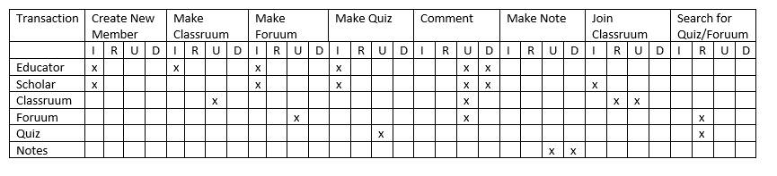

//EXPLANTION NEEDED?

# Interface Design Explanation

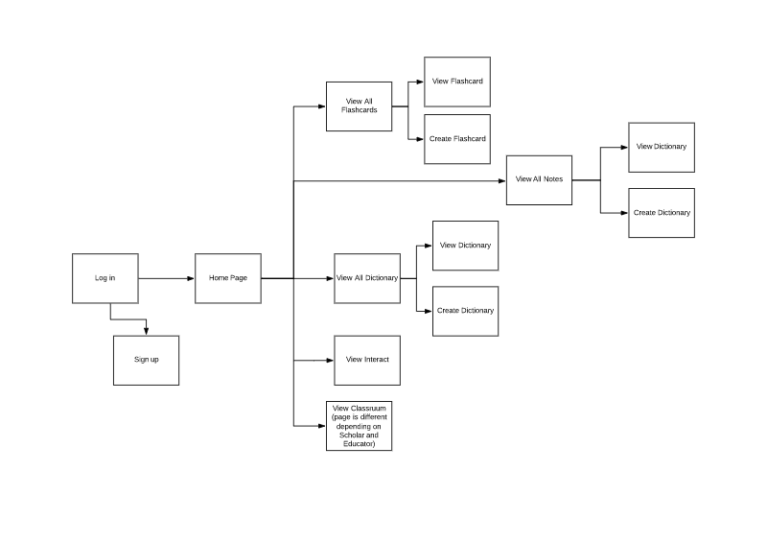

In the initial design for our interface, we had to consider the form and functionality of our program. We have chosen to implement a more professional approach (whilst maintaining our accessibility) compared to the likes of competitor applications (for example Quizlet). This is denoted through our simplistic and minimalistic colour pallet (pastel) and ease of access. to We ensured to fulfil the objectives specified in the requirements whilst maintaining the theme and visual representation of our product.

Our target demographic are students (age 15-25) and teachers. On the next page is an analysis of some of the important aspects to some of the pages, mostly outlining how navigation works through the scenes. The scene numbers to do not generally dictate the order of slides and are used just to refer to the scenes.

**Scene: 1 Log in**

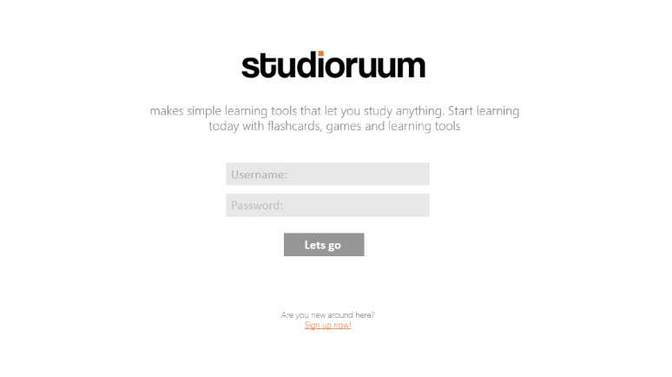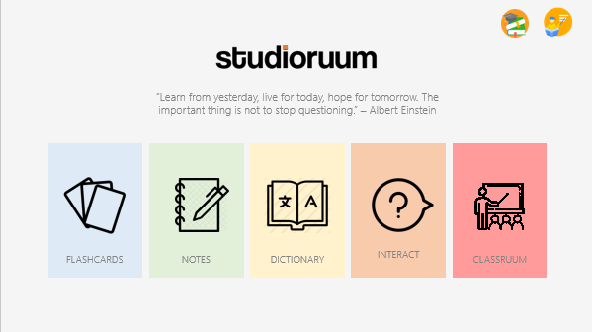

**Scene: 2 Sign up**

User can choose their preferred account type: Scholar or Educator

Button that will take them to home page, and add the users account to the database saving there username/email, password and account type.

If user is new, they can create a new account, which will lead them to the next page: create account.

Button that will take them to home page, if their account credentials are correct. Chose to used colloquial verbiage to connote accessibility, and make the program appear more user friendly.

Greet the user with the logo and a short sentence that explains what our program does.

Log in to an existing account by using usernames and passwords.

**Scene: 3 Home**

If you are using the Educator account type, this icon will appear at top right. Likewise with Scholar

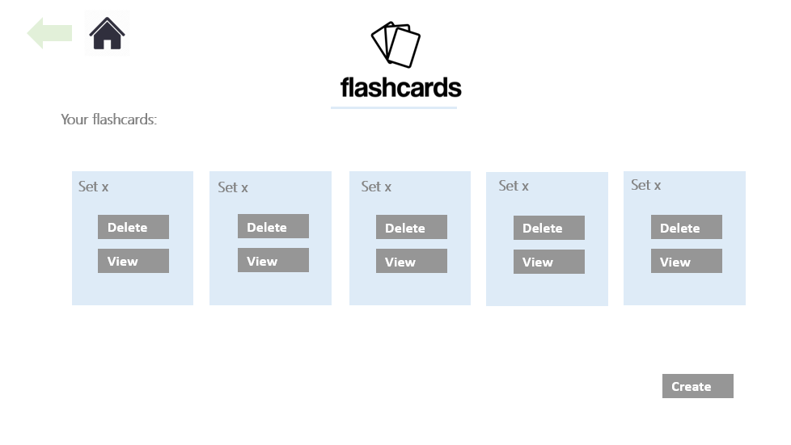 

This shows the users flash card sets, and allows the user to view or delete them

Back button used to navigate to previous page. (Can be used if the user makes a mistake)

**Scene: 4 View flashcards**

This button will take them to the

This will take them to the view dictionaries where they can save and delete sets of dictionaries

This will take them to the view notes where they can save and delete sets of notes

This will take them to the view flashcards where they can save and delete sets of flashcards. (scene 4)

View will take to view flash card page.

Home button takes to home page

This shows the users flash card sets, and allows the user to view or delete them

This indicates the page the user is on.

Short quote that used to inspire the user.

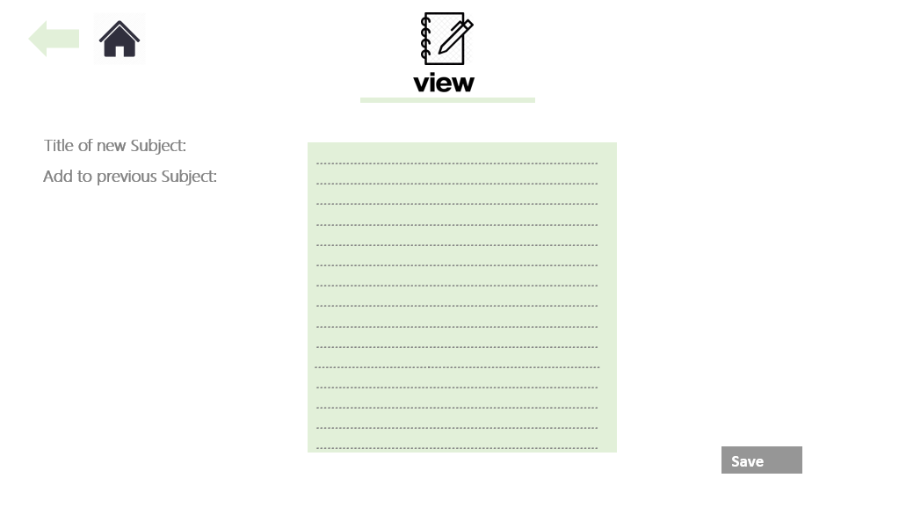

**Page: 9**

Button saves notes to the database and into the subject (new or previous)

Choose whether to name a new set or save note in another subject

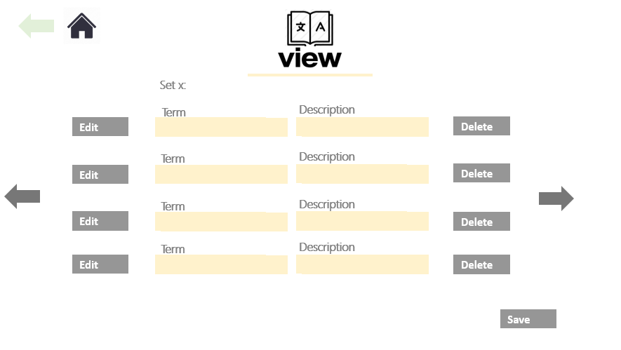

This will delete the attributes in the database.

This will delete the attributes in the database.

# Planning

## Gannt Chart

The Gannt Chart has been updated to show the current work completed so far, along with some rough estimation of the next few weeks. As we are currently starting the planning of the implementation, the planning for that sections remains divided up into the sections discussed in the ***Meeting Minutes***, as those feature a large chunk of the planning completed thus far.

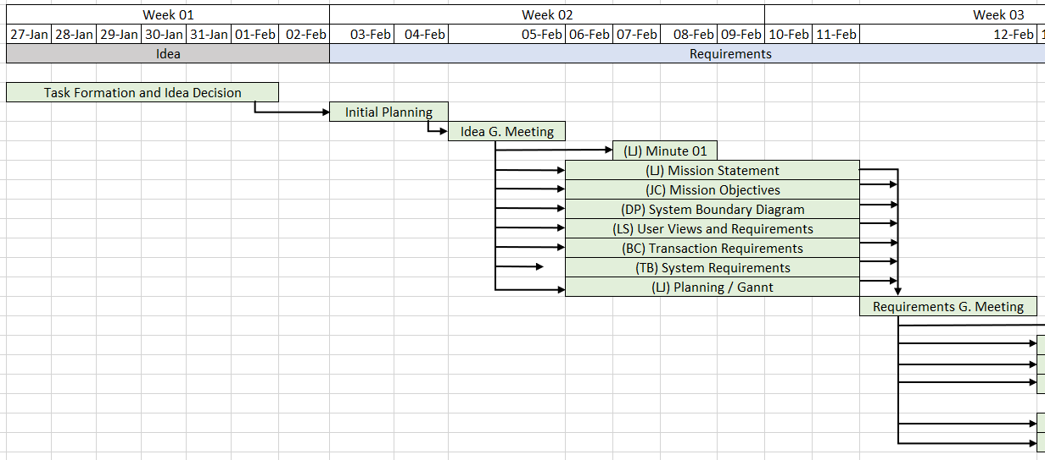

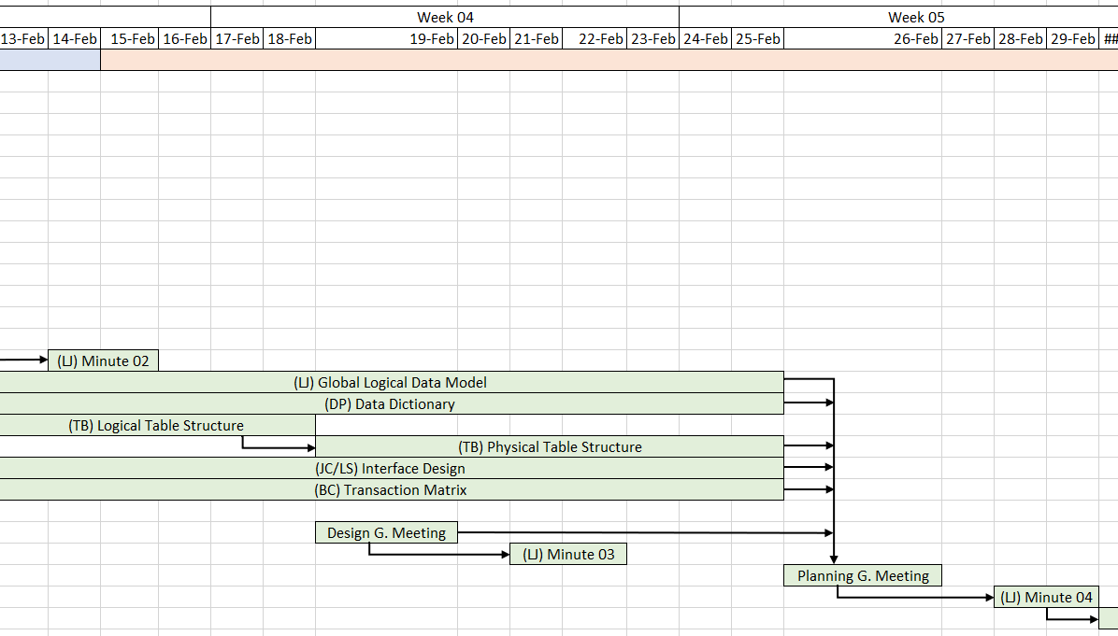

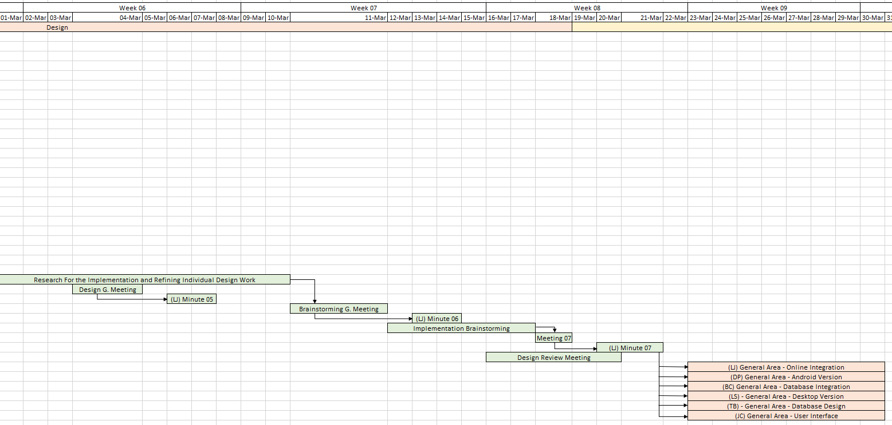

## GitHub Page

The GitHub page has served as the main hub of all planning and file sharing, with most updates filed being placed on here, along with any planning information as shown with the current task allocations.

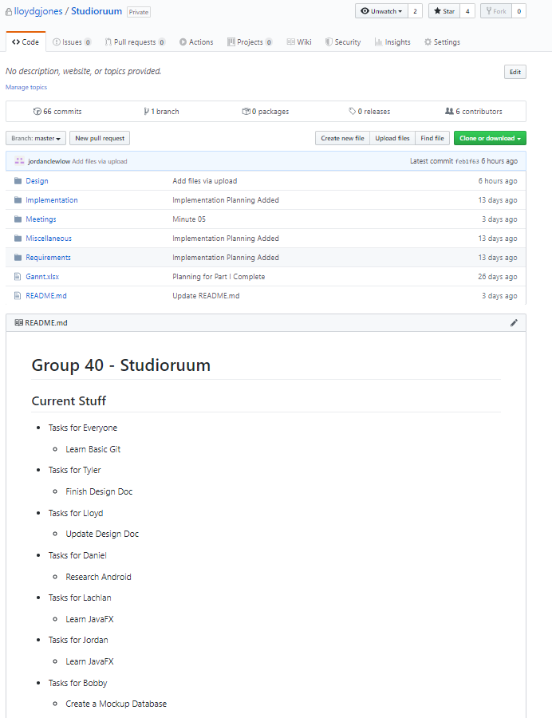

## Discord

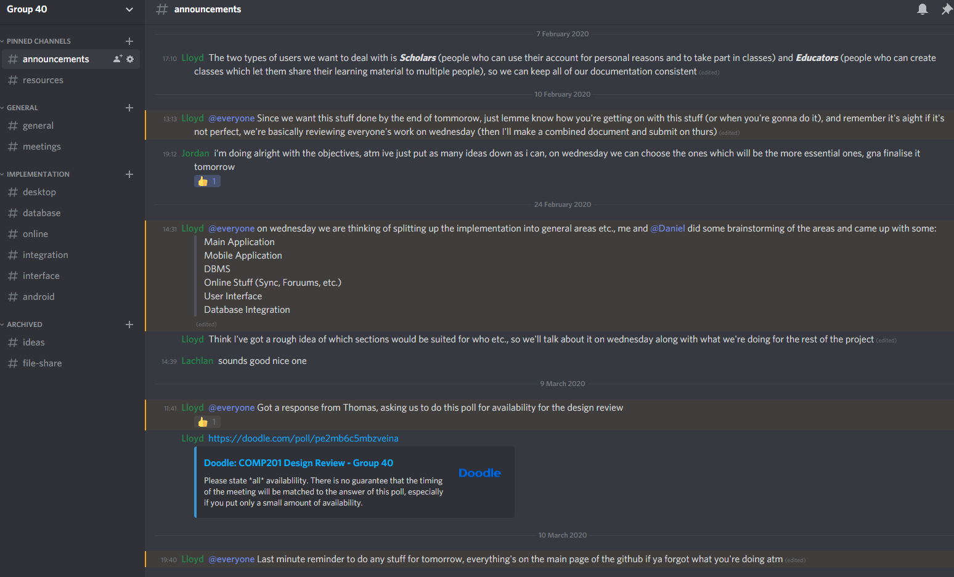

The discord server has also since expanded to have more regular conversation between users, with the screenshot above showing the page of important announcements. Each channel shown on the right has discussion relating to a particular topic, which is used for quicker communication between meetings and to aid in pair/group programming as will be needed for the implementation.

## Technologies

In terms of technologies to be used for the implementation, we have fully settled on ***JavaFX*** for the user interface, due to our familiarity and prior decision to work in Java. The database will be constructed via ***MySQL*** due to it’s widespread nature and appearance in other previous modules. For online storage, the student version of Amazon Web Services has allowed us to use ***Amazon S3 (Simple Storage Service)***, which will host our files, and has a Java API to allow for integration with our desktop application.

## Planning Choices

//GET THIS VIA BRAINSTORMING

# Signatures

In the Order - Lloyd Jones, Daniel Ponturo, Tyler Bunsie, Bobby-Chase Davies, Lachlan Smith, Jordan Clewlow.

